Introducing to Amazon VPC

A. AWS Physical Infrastructure:
+ AWS Cloud infrastructure resides in data centers which contain thousands of servers built into racks. Each rack has network routers and switches to route traffic
+ Data centers are grouped toghether in Availability Zonea (AZs)
+ AZs are connected with single digit milisecond latency network.
+ AZs are grouped toghether in an AWS Regions.
+ Latency between AWS Regions is 10s of miliseconds

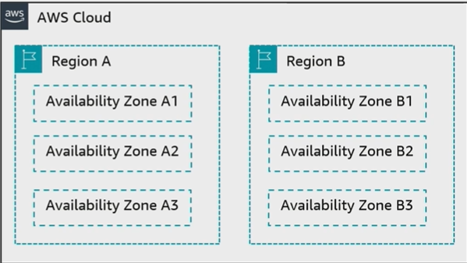

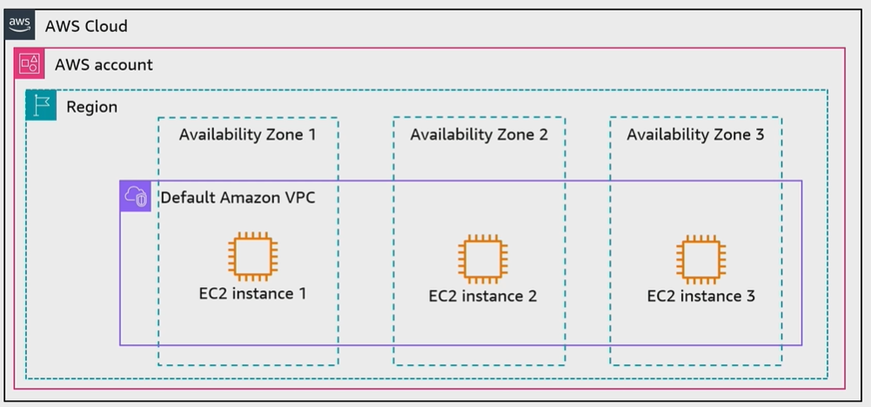
B. AWS account resource isolation

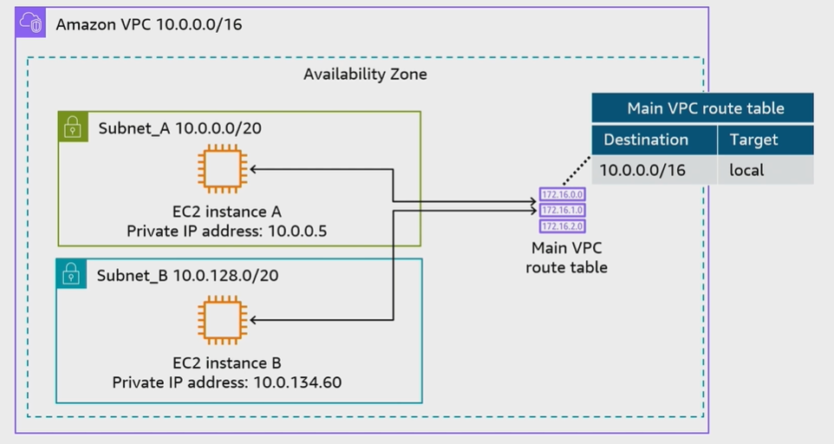
C. Main Route table:

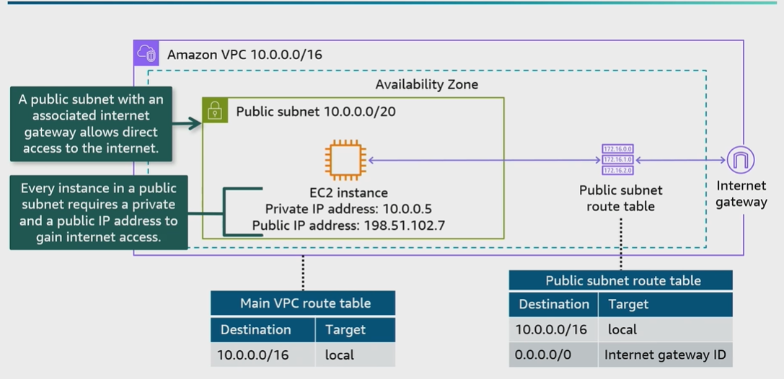
D. Public Subnets;

E. Elastic IP address;

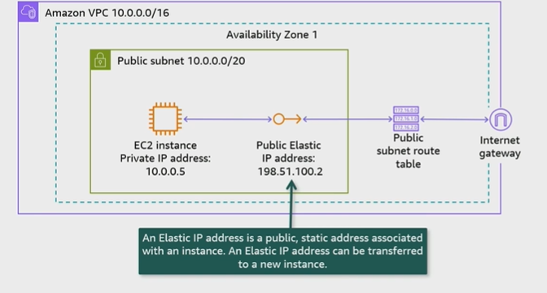

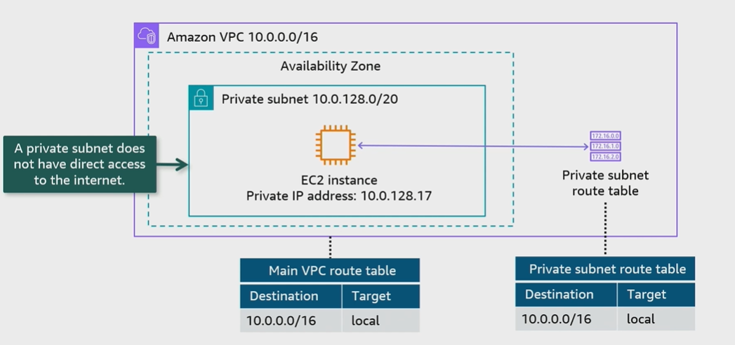
F. Private Subnets;

G. NAT IP mapping:

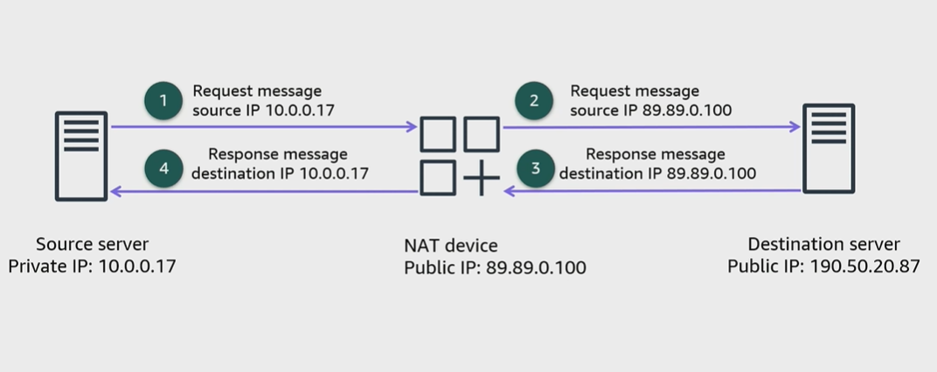
H. Connecting private subnets to the internet
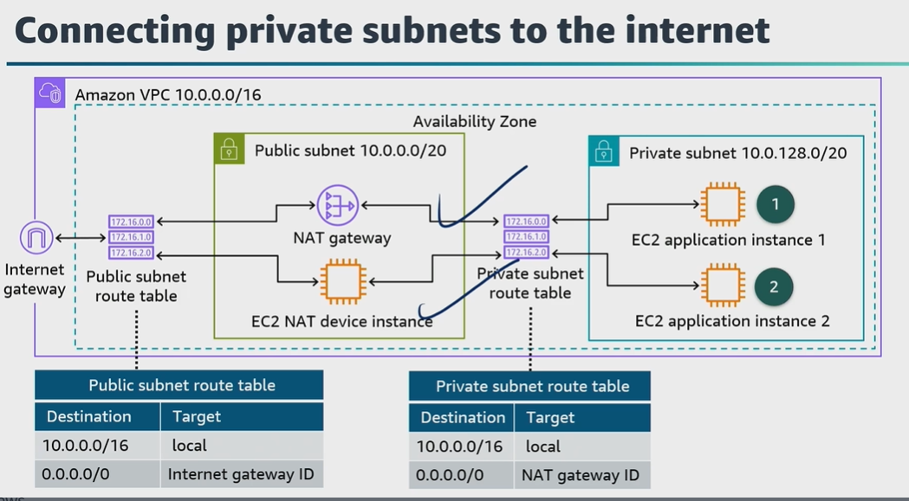

I. Conclusions;
+ An Amazon VPC is a programmatically defined, logically isolated virtual network
+ A public subnet with an internet gateway allows direct access to the internet
+ A private subnet does not have direct access to the internet
+ A NAT gateway allows resource in a private subnet to connect to the internet
+ An Elastic Ip address can be transferred to a new instance.

